‘Mask Burning Parties’ are Triggering the Left (Wing Fascists)

And It Is a Glorious Sight to Behold
March 6, 2021
by Kyle Becker

Normal Americans are over the masks. They are over the lockdowns. They are over the media hysteria.

Who is not “over” all of that is the radical left (wing fascists), which desperately wants Americans to remain paralyzed with fear and completely under the ‘lock down’ control of the Democratic Party.

A New York (Lying) Times reporter has brought attention to a ‘mask burning party” on the Idaho Capitol steps.

The reaction of the left to these videos is either downright ghoulish or steeped in derision.

“Darwinsm in action,” one user tweeted. “A lot of these people are the same people who will refuse the vaccine. Their population/communities will be culled over time due to this rejection of science. I don’t say this with malice. It’s just a fact. I feel for the innocent children.”

“This is some sick stuff right here,” another said. “Guess what else has gone down since people have been wearing masks? Flu, colds, respiratory infections. I hope one day these kids will be embarrassed by this and completely own their parents for their ignorance.”

“What the hell does the rest of the world think when they see things like this?” another added. “We look like a bunch of ignorant hicks jfc.”

“When the next virus comes, and make no mistake, there WILL be another one, and it has a higher mortality than Covid, these people will make certain that as many people as possible die from it,” another commented. “Even if the bodies start to rot in the streets. They will not give a single f***.”
“These parents should be arrested,” David Badash of the New Civil Rights Privileges Movement added.

“The scope of what they are teaching their children includes being anti-science, being selfish, not caring about human life, it’s ok to break the law, and your ‘freedom’ takes priority over other people’s right to live.”

Conservatives, however, welcomed the sight of people taking off their masks and throwing them on the ash heap of history:

Let’s also briefly talk about the “science,” a subject that radical leftists are grossly uninterested in, much less than their vapid moral preening.

The science is not “settled” that masks even work to prevent the spread among the general public. There is no strong evidence that such masks or lockdowns even slow the spread, in terms of cross-national or state-level data.

The viral pandemic exploded in America’s blue states, regardless of mask mandates, while red states that did not have mask mandates compare very favorably. The top four states in deaths per capita were blue states with strong lockdown policies and mask mandates.
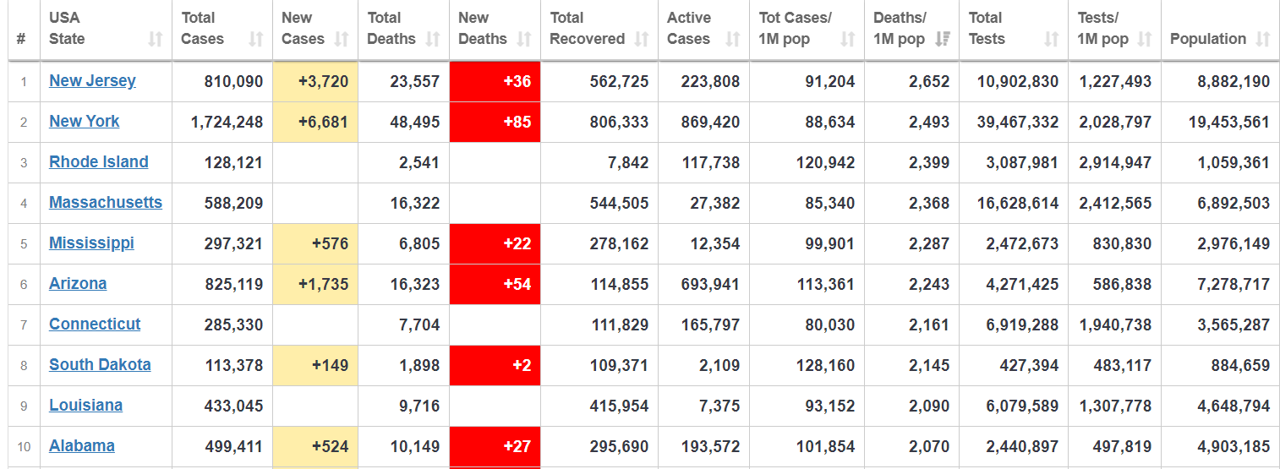
Image credit: Worldometers
Now, we are seeing a massive drop off in infection rates, mortality and hospitalizations, after peaking just after Biden’s election certification.
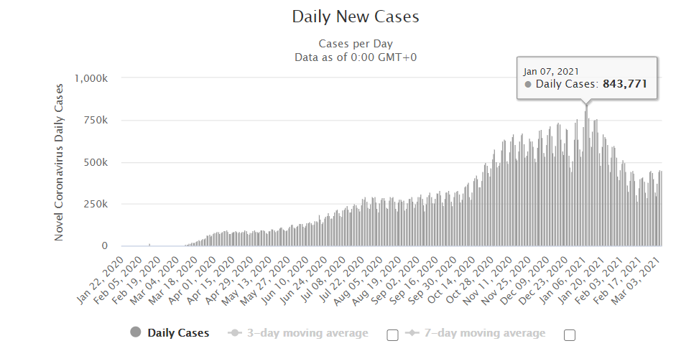
… left (wing fascism) can freak out all it wants that it is losing control over people’s daily lives as the coronavirus pandemic recedes. If you want to show that you are truly free, organize a mask burning party in your own community and upload the video to Twitter.
https://beckernews.com/mask-burning-parties-are-triggering-the-left-and-it-is-a-glorious-sight-to-behold-37519/

