UK cold weather: River Thames freezes over for first time in 60 years.

THE RIVER THAMES in London froze over for the first time in 60 years as temperatures plummeted overnight.

By STEVEN BROWN

PUBLISHED: 15:26, Fri, Feb 12, 2021 | UPDATED: 15:26, Fri, Feb 12, 2021

For the first time since 1963, parts of the River Thames were frozen over as witnesses spotted seagulls perching on the icy surface in Teddington. The River Great Ouse in Cambridgeshire was also frozen over leaving boats stuck.

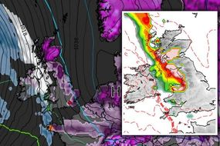
Met Office issues 3 days of weather warnings - blizzards forecast

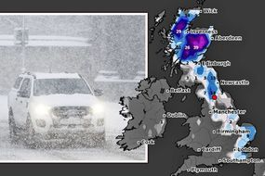
Britain braced for -8C Arctic blast TONIGHT

It comes as temperatures dropped to below 0C in parts of England.
In Ravensworth, North Yorkshire, temperatures plummeted to -15.3C last night as the UK braced for up to four inches of snow and 50 mph gales today.

In Newcastle, families woke up to the city blanketed by snow with the wintry weather also hitting parts of northeast Scotland as well as coastal regions in northeast England.

The Met Office has issued several warnings for snow showers across Scotland with up to 3 cm forecast to fall across Angus and Aberdeenshire.
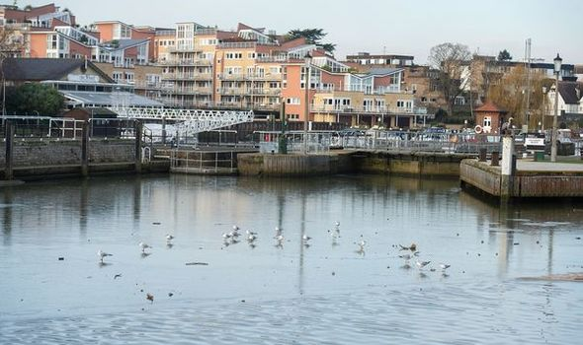
River Thames frozen for the first time in 60 years (Image: Tony Kershaw/SWNS)
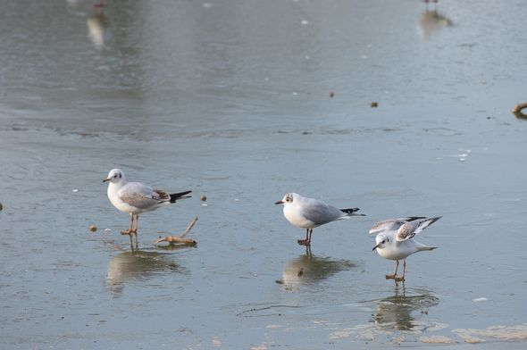
Seagulls seen on the ice after Thames freezes (Image: Tony Kershaw/SWNS)
The weather warning read: "Further snow showers, most frequent on Friday night across Angus and Aberdeenshire, becoming fewer and lighter on Saturday morning.

"Fresh accumulations of 1 to 3cm are expected, but locally 5 to 10cm over higher ground of northeast Scotland.
"In addition, icy stretches will form as any partially melted snow refreezes, especially at lower levels."
The freezing weather comes as 15 weather stations in Britain recorded their lowest temperature ever for February overnight on Wednesday.

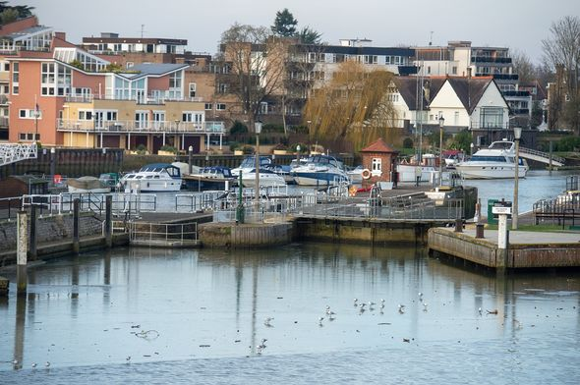
River Thames freezes over for first time in 60 years (Image: Tony Kershaw/SWNS)
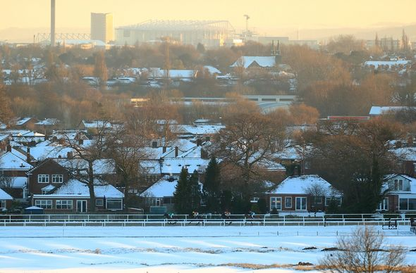
Snow covered Newcastle as temperatures dropped (Image: Getty)

TRENDING

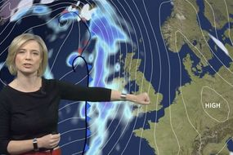
BBC Weather: Freezing snow blizzard to hit UK within hours before heat sweeps over Britain

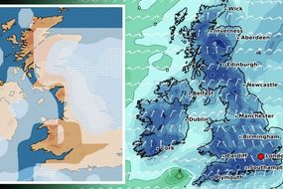
UK snow radar: New chart turns Britain BLUE as freezing Polar bomb forecast to return

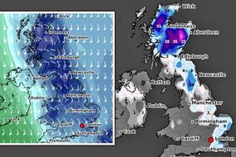
Snow forecast: -11C big freeze to strike in HOURS as heavy snow and blizzards blitz UK
While Scotland recorded its coldest February night since 1955.

Oli Claydon, a spokesperson for the Met Office, said: "Usually you'd expect records to be broken by point such-and-such of a degree but here we are looking at big differences."

Mr Claydon continued: "There's still a couple of days of cold conditions to get through and a little bit more snow in parts of Scotland but the trend is that the weekend is going to herald a change to milder conditions."
He warned there is still chance of freezing rain on Sunday and a yellow warning for ice has been issued by the Met Office.

BBC Weather: UK braces for last day of bitter cold as warm air arrives [INSIGHT]
Long-range forecast: Arctic freeze to ‘dominate’ until March [REVEAL]
Scotland is covered in snow from tip to toe in incredible NASA images [COMMENT]
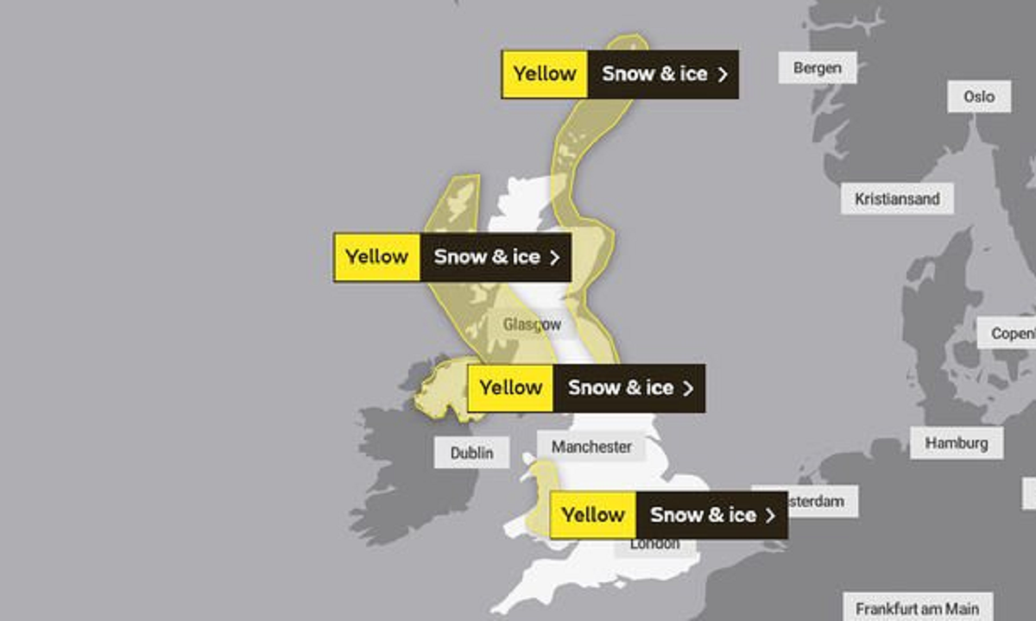
Met Office issues weather warnings across country (Image: Met Office)
Sky News weather presenter Nazaneen Ghaffar said: "Tomorrow the rain, snow and possibly freezing rain will spread eastwards to western parts of Britain.

"It will be very windy across the west too, but temperatures will be higher there than recently.
"Meanwhile, the east will be drier and brighter but colder, apart from some snow showers continuing over northeast Scotland."

While Scotland and northern parts of England experienced snow and colder weather, other parts witnessed wildfires as a result of dried vegetation.
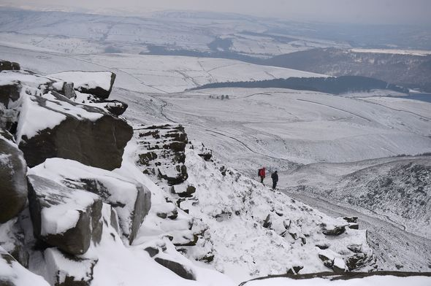
Snow covers Peak District (Image: Getty)
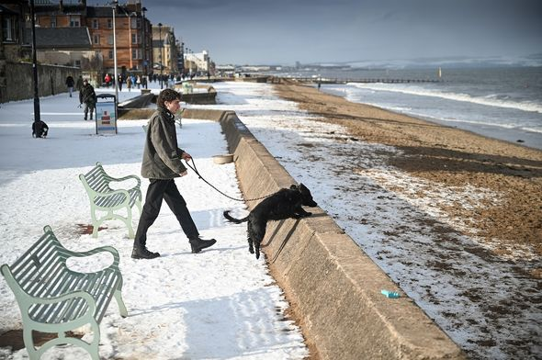
Scotland expected to see more snow fall (Image: Getty)
Devon, Cornwall, and Scotland saw vegetation dry out, according to area commander Bruce Farquharson from the Scotland Fire and Rescue Service.

In Dartmoor, a huge blaze erupted following a spat of fierce winds which engulfed the region.
It is not yet known what sparked the fire.

But a spokesperson for Devon and Somerset Fire and Rescue Service said an investigation is underway.

https://www.express.co.uk/news/weather/1397093/uk-cold-weather-forecast-river-thames-london-picture-freezing-snow-winter-video-met-office

