In Athens, rare snow blankets Acropolis, halts vaccinations

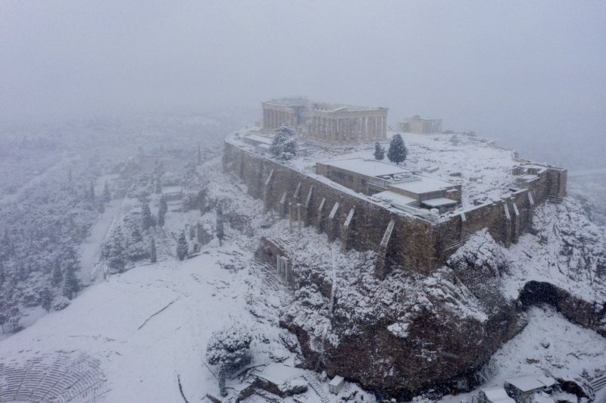
1 of 31
Snow covers the ancient Acropolis hill in Athens, Tuesday, Feb.16, 2021. Unusually heavy snowfall has blanketed central Athens, with authorities warning residents particularly in the Greek capital's northern and eastern suburbs to avoid leaving their homes. (Antonis Nikolopoulos/Eurokinissi via AP)

ATHENS, Greece (AP) — Heavy snowfall blanketed the Acropolis and other ancient monuments in Athens, caused power cuts and halted COVID-19 vaccinations in the Greek capital on Tuesday as the weather brought many services across the country to a standstill.
Greek media reported that three deaths in separate parts of the country were linked with the bad weather. State ERT TV said two elderly men with breathing problems died after their mechanical respiratory aids stopped working due to power cuts, and a farmer on the island of Crete was found dead in a snow-covered area near his sheepfold.
While western Europe got some respite from winter weather, temperatures plunged in the southeast of the continent and storms also battered Turkey.
The snow, an unusual sight in the Greek capital of more than 3 million residents, also stopped most public transport services. Hundreds of toppled trees downed power cables, causing blackouts in several suburbs, while one area on the city’s northern fringes was declared in a state of emergency for the next month. Some of the affected suburbs were also left without water.
Snow is common in Greece’s mountains and in the north of the country, but much rarer in the capital. Some Athenians emerged cautiously outside, snapping photos on balconies and in the streets.
The snow arrived as Athens and several other parts of Greece remain in lockdown to curb coronavirus infections. Schools and most stores are closed, and residents must stay indoors during a nightly curfew.
Some children skipped online classes Tuesday to play in the snow. Adults also went out to play, with some digging out skis to use on the capital’s hilly slopes. One man skied along Pnyx hill in central Athens, near the Acropolis.
Norwegian Ambassador Frode Overland Andersen tweeted a video of himself skiing down a hill in the suburb of Filothei with his teenage daughter.
“Challenge accepted,” he wrote, after a friend in Oslo challenged him to prove it really was possible to ski in Athens.
“It was the best day at my home office during the lockdown so far,” the ambassador told The Associated Press. “Sadly, my skis took a rather hard beating, so I will be waxing and prepping for next season.”
Outside the parliament building, orange snowplows cleared streets of ice and snow, while presidential guards, dressed in traditional pleated kilts and pompom-tipped shoes, were given heavy woolen overcoats.
The cold snap, which has already caused snowstorms around much of Europe, kept temperatures hovering around freezing in Athens on Tuesday but was expected to lift abruptly with highs of 14 degrees Celsius (57 degrees Fahrenheit) expected on Thursday.
In neighboring Turkey, heavy snow and blizzards forced the closure of a highway in northwest Turkey. Around 600 vehicles were stranded on a nine-kilometer (six-mile) stretch of the snow-covered road, and another 800 other vehicles were stranded elsewhere, the state-run Anadolu Agency reported.
Sections of Greece’s main north-south highway were also closed until early Wednesday, leaving about 300 lorry drivers stranded at a highway access point outside Thessaloniki, in northern Greece. Most ferry services to the islands were canceled, while flights from regional airports to Athens were disrupted.
Greek Fire Service spokesman Vassilis Vathrakoyiannis said the service had received hundreds of calls for assistance in greater Athens.
https://apnews.com/article/snow-blankets-athens-halts-vaccinations-be193363451279cc4d105d025d0fb2b6

