Here Are The 'Alt Tech' Platforms Trump Supporters Are Flocking To After Parler Executed By Amazon
BY TYLER DURDEN

THURSDAY, JAN 14, 2021 - 17:20
Over the past week, President Trump has been kicked off of Twitter, Facebook, Instagram, Snapchat, and was blocked from e-commerce platform Shopify - all because of a pair of relatively benign tweets on January 8th, two days after the Capitol 'riot' in which a small group of Trump supporters and a BLM activist were allowed into the Capitol Building through an opened door.
Trump's 'offending' tweets:
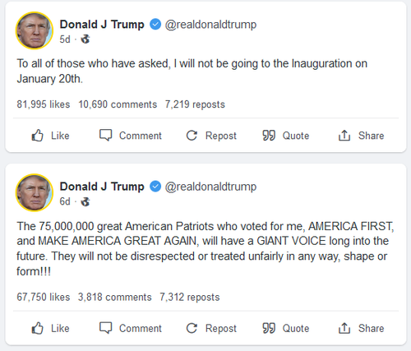Trump's last two tweets which resulted in his permanent ban from the platform, via mirrored account at gab.com
Twitter, likely realizing the 'last straw' used to justify banning a sitting US president was extremely weak sauce (a move which has shocked the world), said the tweets "must be read in the context of broader events in the country."
Furious Trump supporters immediately began to abandon Twitter for so-called 'alt-tech' conservative-friendly alternatives, Parler and Gab.
Over the weekend, however, Amazon and Google banned Parler from their app stores, while Amazon Web Services dealt the death-blow by kicking them off their AWS cloud hosting service, rending the site 'homeless' and inaccessible until they find another host. Thanks to a flood of 'cancel culture' activists targeting all things Trump, Parler continues to be 'dead' for all intents and purposes.
Gab CEO Andrew Torba, meanwhile, backed up Trump's entire Twitter account despite the fact that Trump hasn't yet joined the network (thanks to Jared Kushner, apparently). Torba has been aggressively lobbying for the president to join. The network says it saw a 750% boost in traffic, adding 600,000 new users in a 24-hour period on Monday alone.
"The traffic just keeps growing. Hang tight, even more servers on the way today," Torba wrote on Saturday.
Where else are Trump supporters flocking?
With Parler currently unpersoned by big tech, and Gab's servers running a little slow thanks to the influx of Twitter and Parler refugees, several other social media apps and platforms are seeing record traffic.
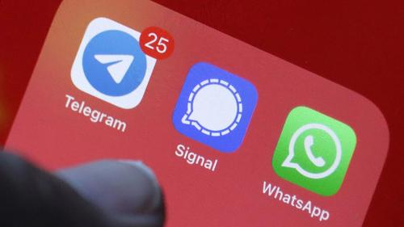
Telegram: Before Parler was taken to the woodshed by Amazon, influential users began calling on users to move to messaging app Telegram, where Donald Trump Jr. actively posts in a public channel. The service offers end-to-end encryption outside of Big Tech's grasp, according to the Wall Street Journal.
One Telegram channel had over 16,000 "Parler refugees" as of Jan. 11, while the service announced on Tuesday that it had attracted 25 million new users globally in the preceding 72 hours, bringing its total active user base to 500 million.
The platform supports up to 200,000 members in a group, which is why it's a favorite go-to for protesters in Hong Kong, Iran, and Belarus.
Signal: Widely regarded as the most 'private' app, Signal's encryption is open source. It also offers encrypted calling and video chat. Between last Thursday and Sunday, the app saw around 7.5 million installations from the App Store and Google Play, around 43x more than it received the previous week, according to CNN.
The flood of new users has caused some glitches, however, with the company tweeting on Thursday that verification codes for new sign-ups may be delayed "because so many new people are trying to join Signal right now (we can barely register our excitement)."
"We are currently having a record level of downloads for the Signal app around the world," the company said in a Friday Reddit post.
Last week, Signal received some high-profile endorsements after Elon Musk, currently the richest man on the planet, tweeted "Use Signal." Twitter CEO Jack Dorsey retweeted it - later posting an image of Signal at the top of the App Store chart after it displaced Parler as the #1 download.
Edward Snowden also retweeted Musk, adding "That's @signalapp, for those who don't speak Elon."
Other platforms receiving attention of late include; video sharing sites Rumble and BitChute, livestreaming service DLive, along with CloutHub, MeWe and Minds.com.
What's out? WhatsApp...
After the Facebook-owned 'secure' messaging app announced a new privacy policy which states that the company may share user data with other Facebook companies "to help operate, provide, improve, understand, customize, support, and market our Services and their offerings," users began abandoning the app.
In Hong Kong, users have been leaving WhatsApp left and right, according to nikkei.com.
It is an indication that people in the city have joined social media users around the globe in a shift to other messaging platforms because of concerns over privacy, after WhatsApp dismayed many users by rewriting its terms of use on Jan. 6.
The new terms will essentially allow Facebook, WhatsApp's owner, to gain access to certain personal information, such as contact lists, location, financial information, and usage data.
Since then, WhatsApp's rivals have seen a record-breaking amount of downloads. -nikkei
One thing is for sure; with Trump kicked off Twitter, Parler currently dead, and ensuing refugees flocking to a bevy of alternative social media platforms that are siloed from each other, the conservative social media ecosystem has never been more fractured. Mission accomplished; we can only assume.
https://www.zerohedge.com/technology/here-are-alt-tech-platforms-trump-supporters-are-flocking-after-parler-executed-amazon

